**Millionaire’s Hot Chocolate**

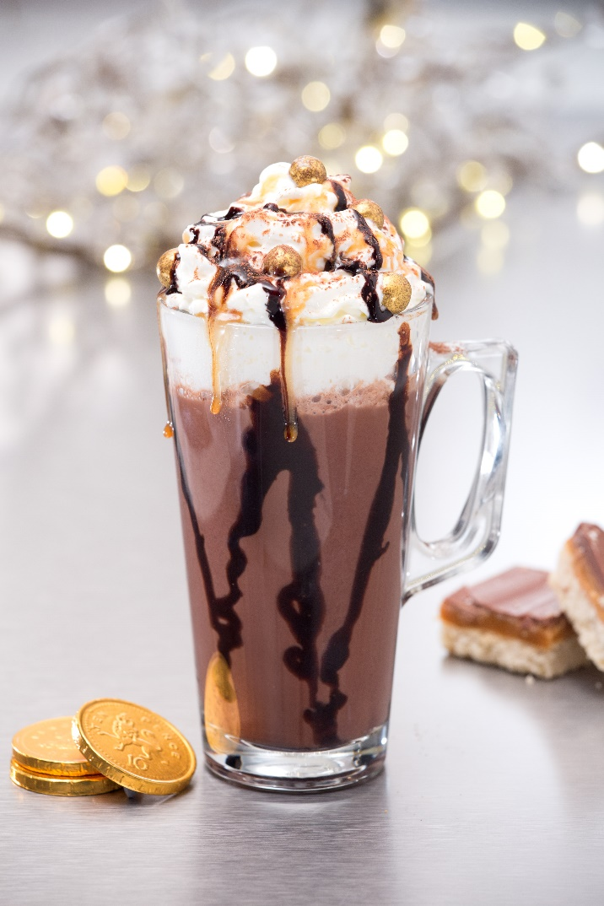

**Ingredients / Equipment:**

**Zhoca Chocolate Powder**

**Milk**

**Caramel Syrup & pump**

**Caramel sauce and drizzle bottle**

**Chocolate sauce and drizzle bottle**

**Whipped Cream (optional)**

**Large Latte glass (13oz)**

**Method:**

**Place approx. 1cm of hot water into bottom of clean milk jug.**

**Add 1 heaped scoop of Zhoca powder and mix with mini whisk for 5 seconds.**

**Add 3 pumps of Caramel syrup.**

**Add cold milk to the jug (to standard level) and heat.**

**Drizzle chocolate sauce up and down inside of latte glass/cup and pour hot chocolate into glass, stopping approx. 2cm from the top.**

**Squirt whipped cream to form a crown, finish with golden balls and drizzle chocolate & caramel sauce over the top.**