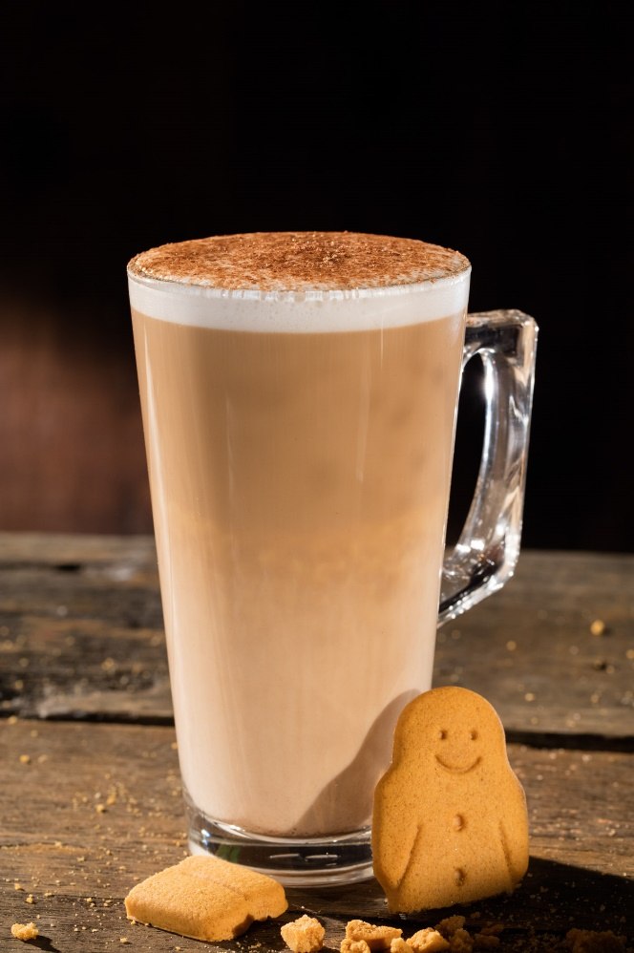

**Ingredients / Equipment:**

**Coffee**

**Milk**

**Gingerbread Syrup & pump**

**Gold dust shaker**

**Large latte glass**

**Method:**

**Extract a double shot of espresso into a small jug.**

**Add 3 pumps of Gingerbread syrup into the extracted coffee.**

**Heat latte milk and pour into Latte glass stopping approx. 1cmfrom the top.**

**Pour infused coffee into centre of latte milk**

**Sprinkle gold dust powder across top of drink to finish.**

**Gingerbread Latte**